

TRADEWINDS INTERNATIONAL INSURANCE BROKENS SDH BHD

DMMS Application USER GUIDE

**Table of Contents**

Introduction …………………………………………………………………………………………………………………2-3

To start run DMMS application in Windows Based …………………………………………………….…….4- 5

DMMS User log in in windows based 6-9

Upload Bank data file and Insurance file 10-11

Data file verification in process 12-14

Data file merging in process 15

Data file merging successful 16

Pulling report information from DMMS database ….……………………….………………….……………… 17

Report 2 category **“Status Report”** and **“Detail Report”**  18-33

To start run DMMS application in Web Based ………………………………………………………………….. 34

DMMS User log in in Web Based 35-37

Add new insurance policy with new single insurance policy…………………………………………… 38-41

Search for single insurance policy ………………………………………………………………………………42- 43

Generate letter note for those policy already expire and renewed the insurance policy …..44 - 47

Payment settlement…………………………………………………………………………………………………..48 -51

Debit Note Summary ………………………………………………………………………………………….……52 - 58

# 1.0 Introduction

The DMMS is a one of the system where to **filtering rust data** ,**merging two different source** and **store into secure database**. The purpose is use for speed up process of renewal Premium insurance policy and easy make a payment and update new insurance policy.

The functionality of **filtering rust data** is use for checking all the data uploaded by user to confirm is meet the system requirement before doing data merging. The **data merging function will start after filtering rust data successful.** DMMS also provide **online update single insurance policy / add new customer insurance policy**

In this Data Merging and Management System contains 2 parts: which is

1. Windows Based application which use by internal user (TIIB user).
2. Web Based application which use external user(BMM user) or (TIIB user)

**Windows Based application**

In the Windows Based Application normally use for **filtering rust data** and **data merging** and also able to **pulling out clear data** which use by DMMS user in daily report**.**

**Web Based application**

In the Web Based Application normally use for **add new customer information, editing single line customer profile**  and **generate summary report with flexible date select** use by DMMS user in daily report**.**

**Tip:**

*Note: *** indicate as caution*

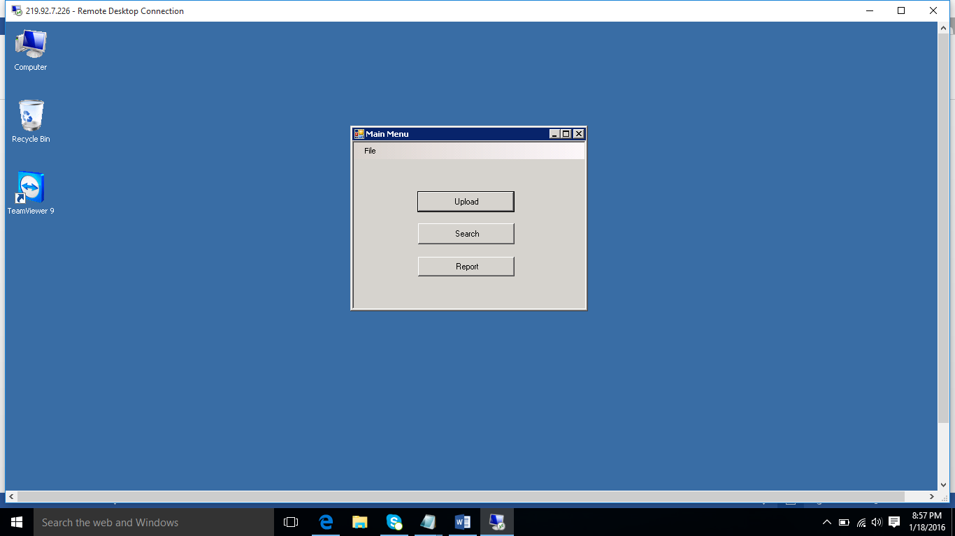

**Figure 1.0 : DMMS in windows based**

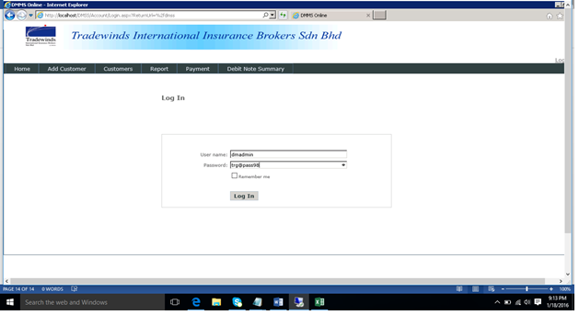

**Figure 1.1: DMMS in Web Based**

**2.0 To start run DMMS application in Windows Based**

After gathering feedback from all DMMS user acknowledge, we have do the conclusion final design the user guider for All DMMS user, to guide how operate the DMMS application in Windows based and Web based . DMMS user is easy to start operate the DMMS application because we have provide the clear snap shoot picture and Standard Of Procedural (SOP) step by step. Let go we start to learn how to DMMS application in windows Based.

**Step no 1.**

**DMMS User log in Active Directory**

DMMS user have to log in the TIIB Active Directory (AD)before start to execute DMMS windows based because DMMS Server is controlling each single user profile and once DMMS user successful to log in Active Directory (AD), DMMS user able to see DMMS icon inside PC desktop screen *example figure 1.0 DMMS application display in PC desktop.*

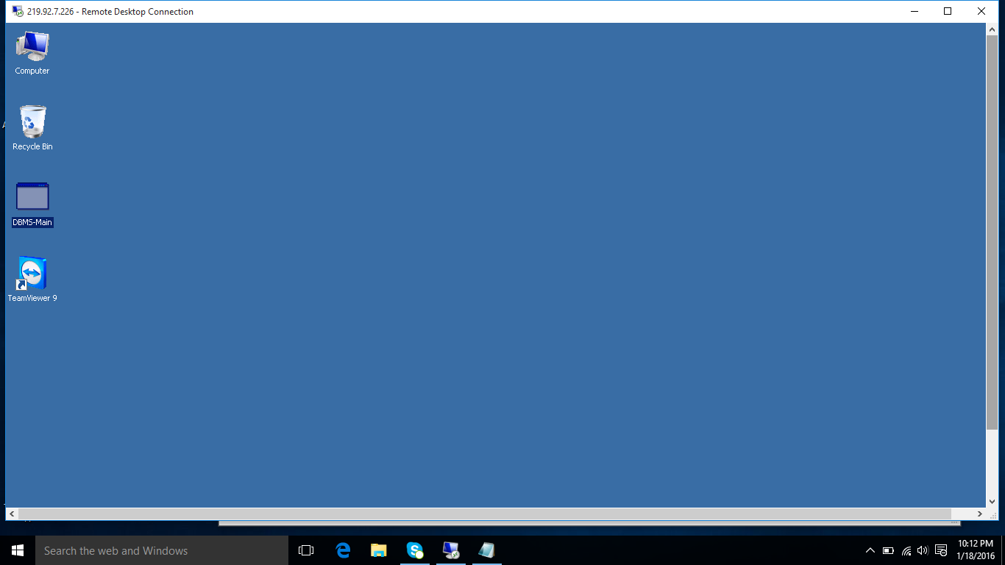

DMMS application

**Figure 1.0: DMMS application display in PC desktop.**

**Tip:**

*Note: *** indicate as caution*

**Step no 2.**

**DMMS User run DMMS .exe**

DMMS user have to double click the DMMS icon where display into desktop or right click in mouse button and choose “Run as”, *example figure 1.1: Right click in mouse button and choose “Run as”.*

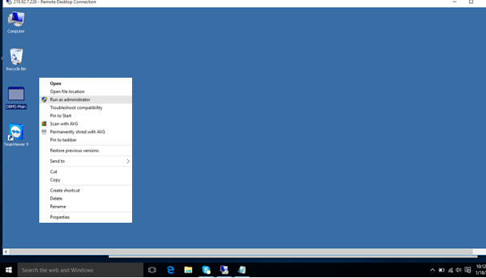

**Figure 1.1: Right click in mouse button and choose “Run as”.**

**Tip:**

*Note: *** indicate as caution*

**Step no 3.**

**DMMS User Log in Page**

After DMMS user have started click the DMMS icon that DMMS window based application will start to run and will require DMMS user to entry the user name and password, *example figure 1.2: Entry the User name and Password*

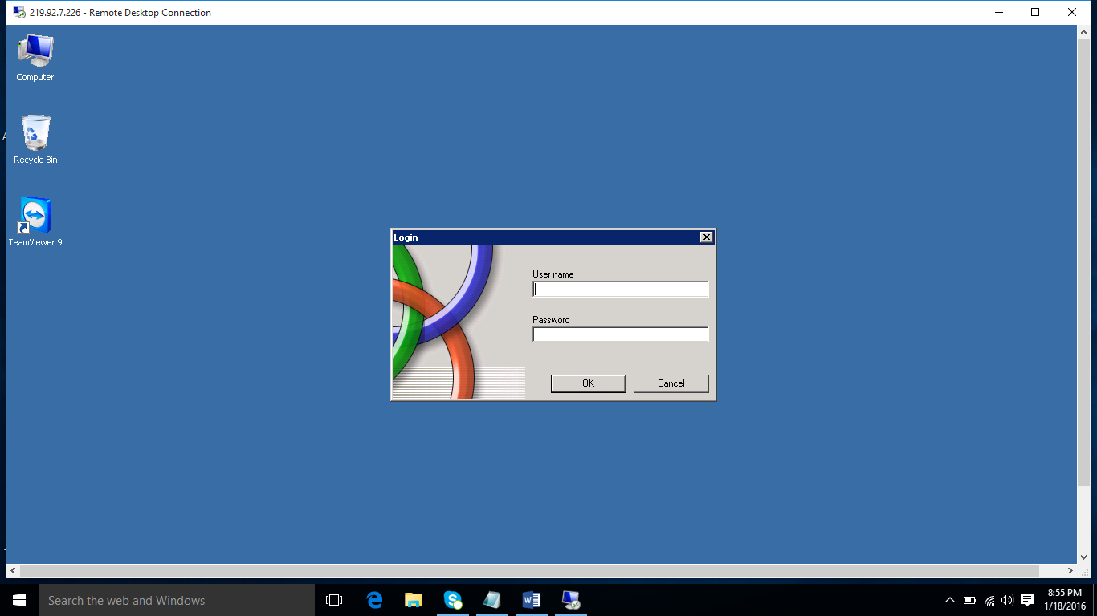

**Tip:**

*Note: *** indicate as caution*

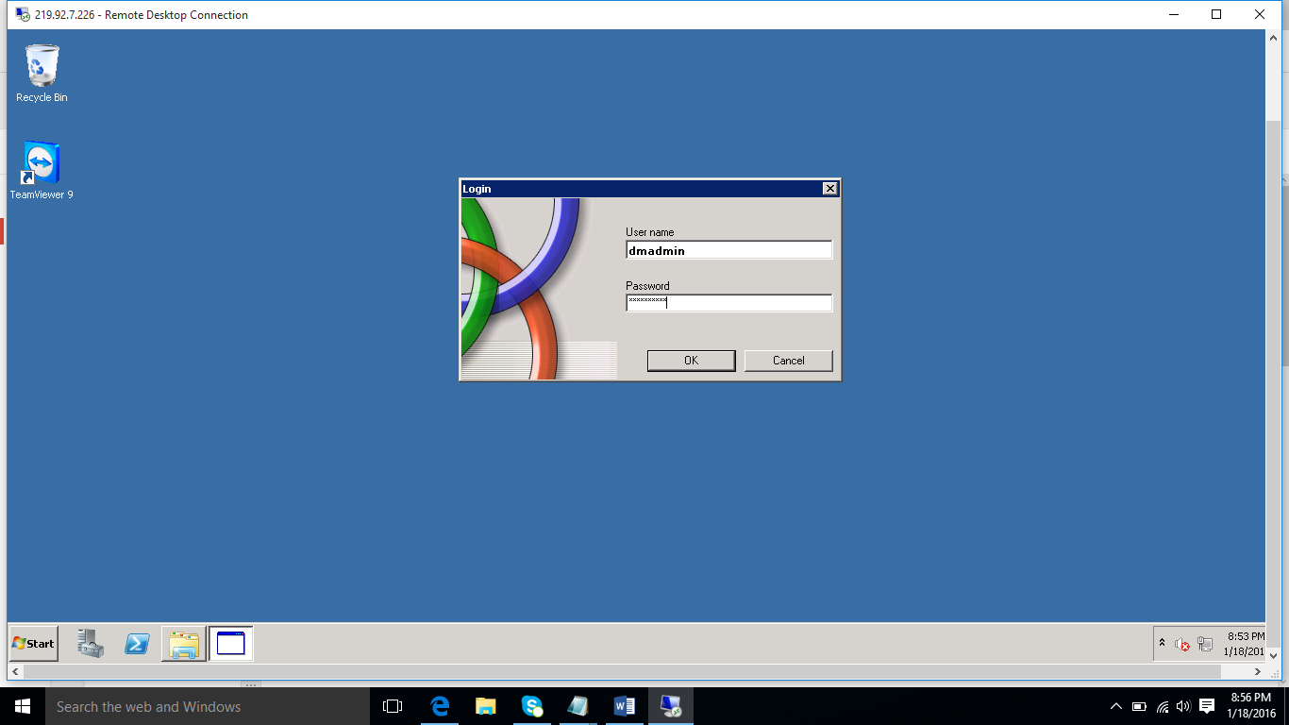

**Figure 1.2: Entry the User name and Password**

***\*\*\* Error Message to entry User name and invalid password***

If DMMS user entry wrong password or user name, DMMS application will return error message *example figure 1.3: Invalid user name or password, please try again.*

**Tip:**

*Note: *** indicate as caution*

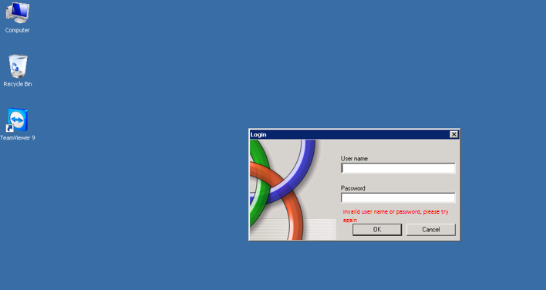

**Figure 1.3: Invalid user name or password, please try again**

**Step no 4.**

After the DMMS user successfully to login the DMMS application, DMMS user will able to see the whole DMMS application background, *example figure 1.4 DMMS application windows Based.*

**Tip:**

*Note: *** indicate as caution*



**Figure 1.4 DMMS application windows Based.**

**Tip:**

*Note: *** indicate as caution*

**Step no 5. Upload file**

To start merge input files, DMMS user have click on the **“Upload”** button on DMMS windows based application, *example figure 1.5: “Upload button”*



**Figure 2.5: “upload button”**

**Tip:**

*Note: *** indicate as caution*

**Step no 6 Browse Bank and Insurance location**

Then DMMS user have select bank file and insurance file location before upload the file to DMMS application, click the “Browser button” on the right side ,*example figure 1.6 Selecting bank file and insurance file location.*

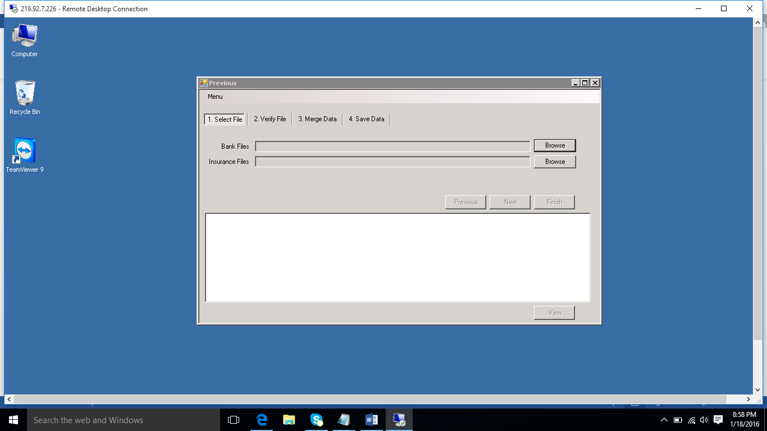

**Figure 2.6 Selecting bank file and insurance file location.**

Once DMMS user click the “Browser button” Bank file or Insurance file location, DMMS user have to select the file location *example figure 1.7: File location*

**Tip:**

*Note: *** indicate as caution*

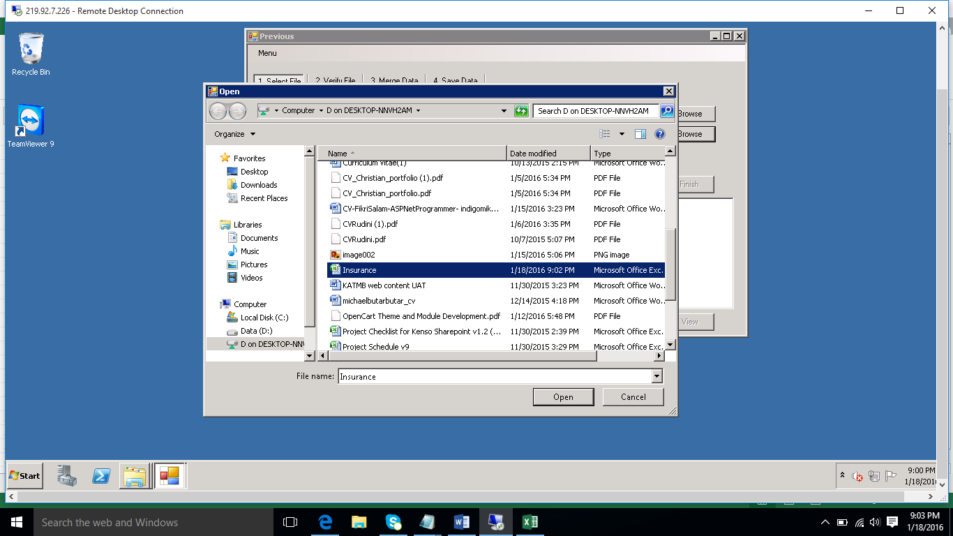

**Figure 1.7: File location**

Once the files are selected, user need to click on “**Next”** button to proceed, *example figure 1.8 import the Bank file and Insurance file in the DMMS application.*

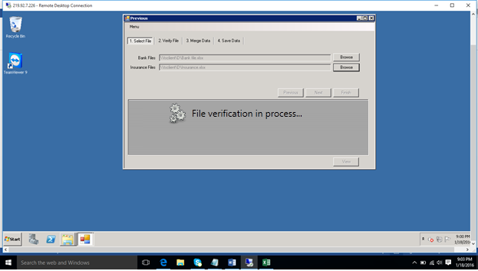

**Figure 1.8: Import the Bank file and Insurance file in the DMMS application.**

If user have uploading the one of the file where duplication line or invalid ic no or not meet the criteria that the DMMS application will stop to process next step and show the error message *example figure 1.9 File Verification fail.*

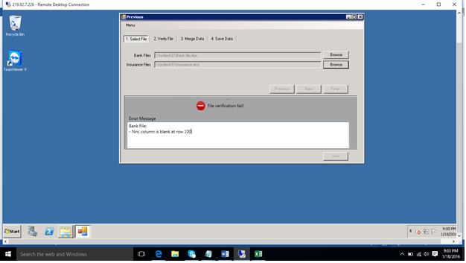

**Figure 1.9 File Verification fail**

But if the File verification successful for both file and both data where DMMS user uploading, the DMMS application will showing both file in the table, *example figure 2.0 File Verification successful.*

**Tip:**

*Note: *** indicate as caution*

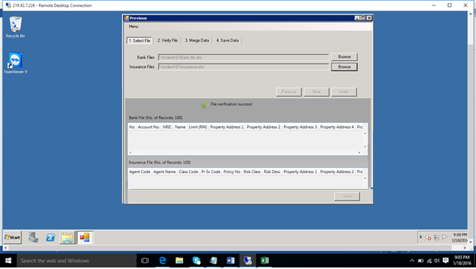

**Figure 2.0 File Verification successful**

**Tip:**

*Note: *** indicate as caution*

**Step no 7. Data merging process**

Click “Next” button to continue next step data merging, *example figure 2.1 Input file are merged successfully*

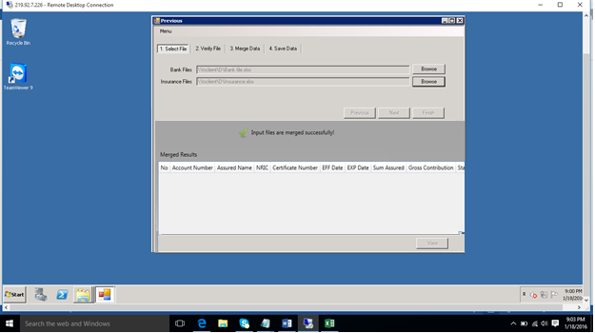

**Figure 2.1 Input file are merged successfully**

**Tip:**

*Note: *** indicate as caution*

**Step no 8. Data merging Successful**

DMMS application require user to give name where the data successfully merged before storage DMMS database, *example figure 2.2 File name for data merged.*

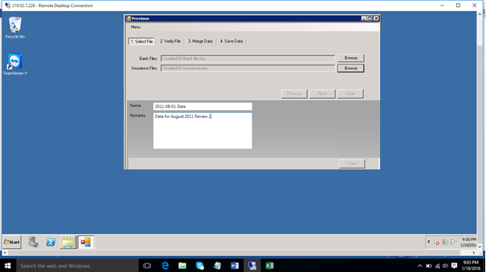

**Figure 2.2 File name for data merged**

**Tip:**

*Note: *** indicate as caution*

**Pulling report information from DMMS database**

As previous step process, DMMS user is execute the file data merging and stored into DMMS database and that now DMMS user able pulling data information based on few requirement where ready functionally in the DMMS application, every DMMS user able to pulling the data from database in click the button ready make in the system, let go we have taken a look how the DMMS pulling the data from database.

In this pulling data function, the DMMS application named as “Report” in the system and user have to click the button called Report inside the DMMS application ,*example figure 3.0 “ Report Button” inside the DMMS windows based application*



**Figure 3.0 Button called Report inside the DMMS application**

**Tip:**

*Note: *** indicate as caution*

When DMMS user click the button called “Report” in DMMS windows based application, the next screen will showing report 2 category, these are **“Status Report”** and other category is **“Detail Report”,** *example figure 3.1 DMMS Report user interface.*

The **“Status Report”** – DMMS application pulling data from database based on certain row and column.

**“Status Report” in DMMS application consist;**

* Summary by Insurer overall
* Summary by Branches overall
* Summary by Branches and Insurer overall

But **“Detail Report”** – DMMS application is pulling ALL data from database.

**“Detail Report” in DMMS application consist;**

* Detail Report- Branches
* Detail Report- Branches Active
* Detail Report- Branches Expire
* Detail Report- Branches Status

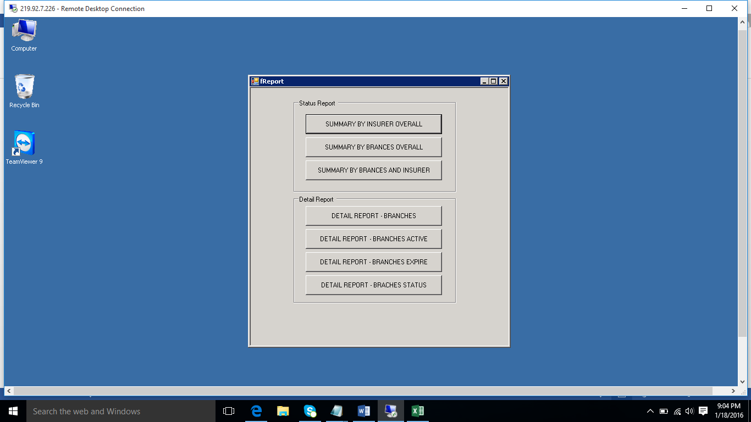

**Figure 3.1 DMMS Report user interface.**

The **“Status Report”** – DMMS application pulling data from database based on certain row and column.

**“Status Report” in DMMS application consist;**

* Summary by Insurer overall
* Summary by Branches overall
* Summary by Branches and Insurer overall

**Summary by Insurer overall**

If DMMS user want to review how many insurer and status case, DMMS user have to click the button under name “ Summary by Insurer overall”, *example figure 4.0 Summary by Insurer overall.*



**Figure 4.0 Summary by Insurer overall**

**Tip:**

*Note: *** indicate as caution*

DMMS user able to export the data to Excel file, just click the button called **“Excel”**, *example Figure 4.1 Summary by Insurer*

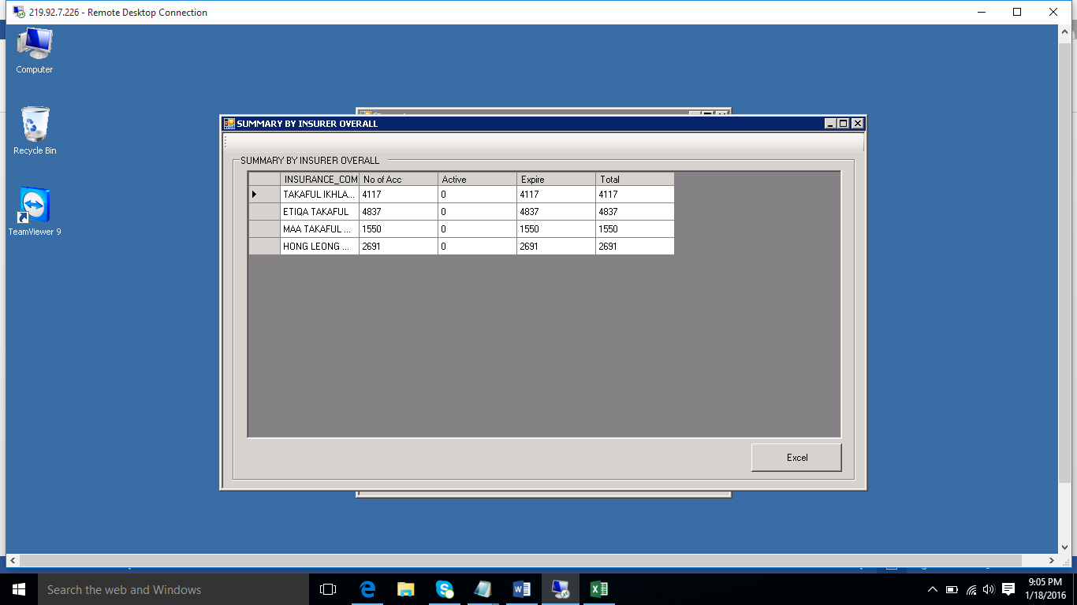

**Figure 4.1 Summary by Insurer**

**Tip:**

*Note: *** indicate as caution*

**Summary by Branches overall**

If DMMS user want to review how many Branches and status case, DMMS user have to click the button under name “Summary by Branches overall”, *example figure 4.2 Summary by Branches overall button.*



**Figure 4.2 Summary by Branches overall button**

**Tip:**

*Note: *** indicate as caution*

DMMS user able to export the data to Excel file, just click the button called **“Excel”** *example figure 4.3 Summary by Branches overall button.*

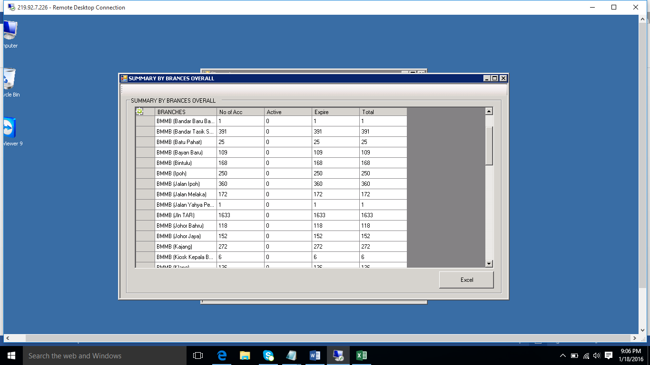

**Figure 4.3 Summary by Branches overall**

**Tip:**

*Note: *** indicate as caution*

**Summary by Branches and Insurer overall**

If DMMS user want to review how many Branches with many insurer and status case, DMMS user have to click the button under name “Summary by Branches and Insurer overall”, *example figure 4.4 Summary by Branches and Insurer overall.*



**Figure 4.4 Summary by Branches and Insurer overall button**

**Tip:**

*Note: *** indicate as caution*

DMMS user able to export the data to Excel file, just click the button called **“Excel”** *example figure 4.5 Summary by Branches overall.*

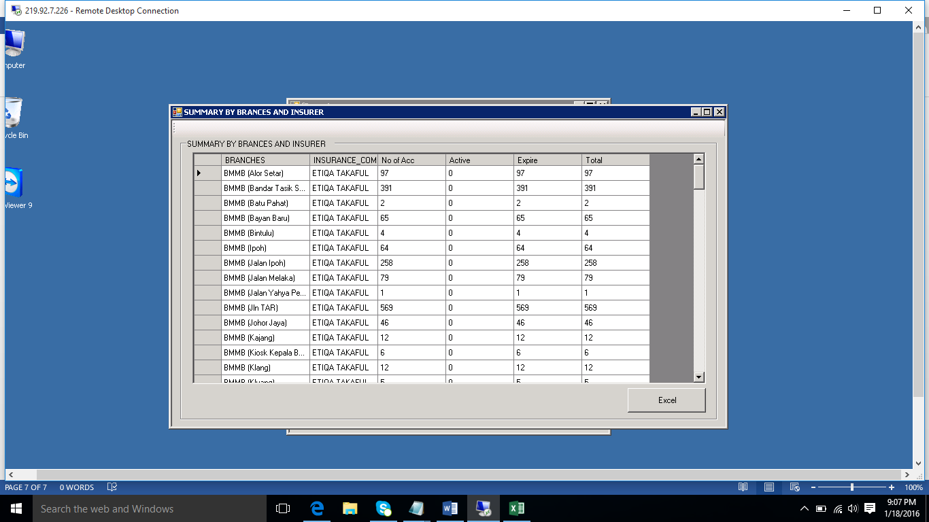

**Figure 4.5 Summary by Branches and Insurer overall**

**Tip:**

*Note: *** indicate as caution*

**“Detail Report”** – DMMS application is pulling ALL data from database.

**“Detail Report” in DMMS application consist;**

* Detail Report- Branches
* Detail Report- Branches Active
* Detail Report- Branches Expire
* Detail Report- Branches Status

**Detail Report- Branches**

If DMMS user want to review report Branches in detail, DMMS user have to click the button under name “Detail Report- Branches”, *example figure 5.0 Detail Report- Branches button.*



**Figure 5.0 Detail Report- Branches button**

**Tip:**

*Note: *** indicate as caution*

DMMS user able to export the data to Excel file, just click the button called **“Excel”** *example figure 5.1 Detail Report- Branches*

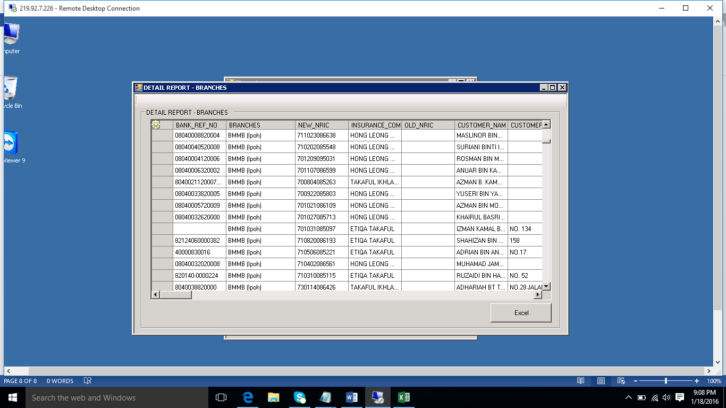

**Figure 5.1 Detail Report- Branches**

**Tip:**

*Note: *** indicate as caution*

**Detail Report- Branches - Active**

If DMMS user want to review how many policy in the Branches still active in detail, DMMS user have to click the button under name “Detail Report- Branches active ”, *example figure 5.2 Detail Report- Branches active button.*



**Figure 5.2 Detail Report- Branches active button.**

**Tip:**

*Note: *** indicate as caution*

DMMS user able to export the data to Excel file, just click the button called **“Excel”** *example figure 5.3 Detail Report- Branches active*

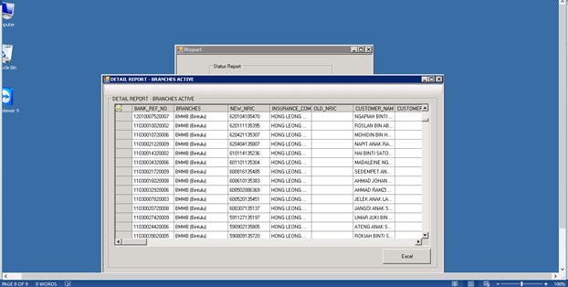

**Figure 5.3Detail Report- Branches active.**

**Tip:**

*Note: *** indicate as caution*

**Detail Report- Branches - Expire**

If DMMS user want to review how many policy in the Branches already Expire in detail, DMMS user have to click the button under name “Detail Report- Branches Expire.



DMMS user able to export the data to Excel file, just click the button called **“Excel”**

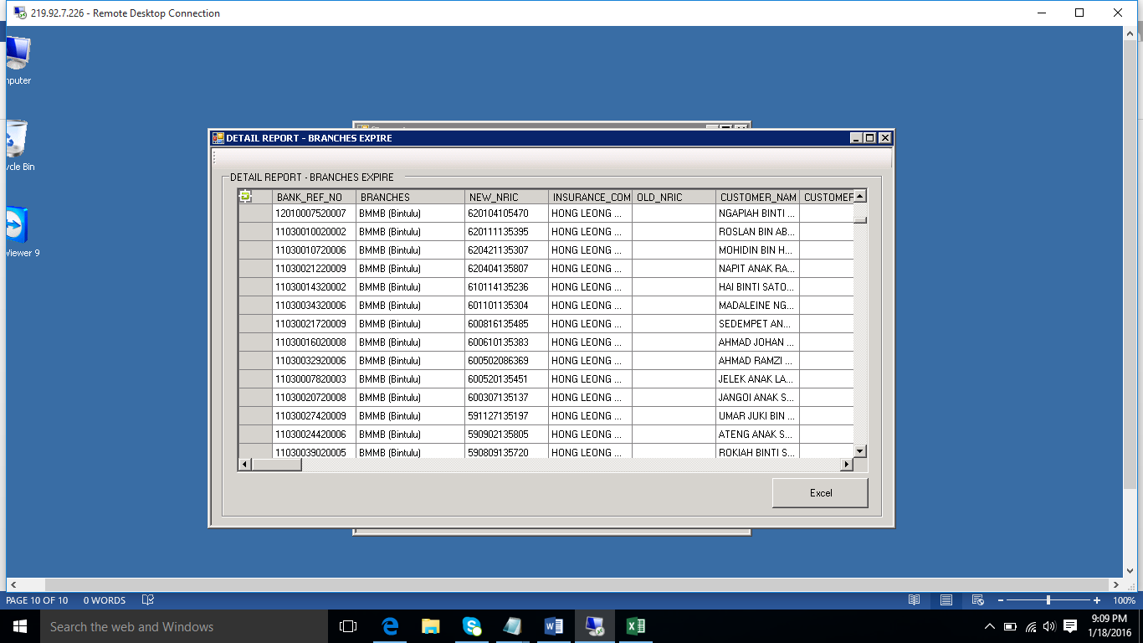

**Figure 6.1 Detail Report- Branches Expire.**

**Detail Report- Branches status**

If DMMS user want to review Branches status with filtering each Branches in detail, DMMS user have to click the button under name “Detail Report- Branches Status”



**Figure 6.2 Detail Report- Branches Status**

**Tip:**

*Note: *** indicate as caution*

**Step no 1.**

Selecting the Branches available in the DMMS database, *example figure 6.2a : selecting the Branches*

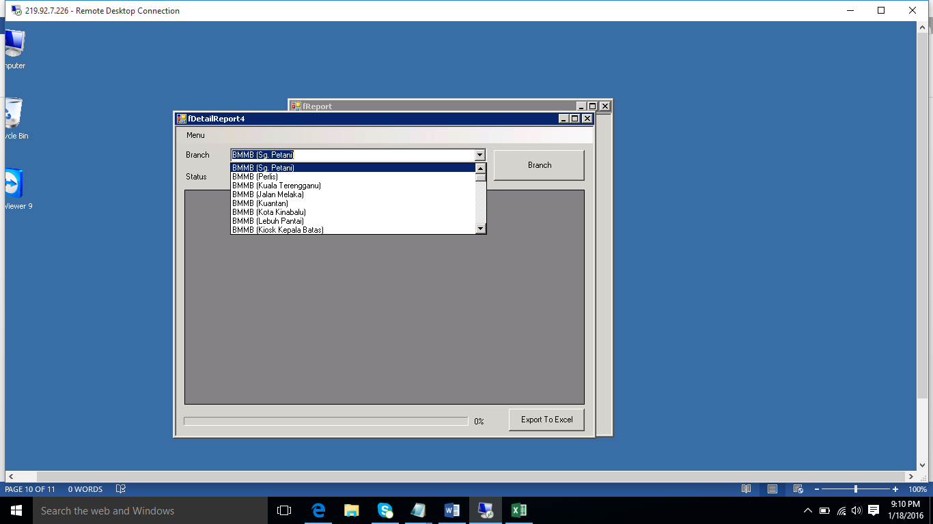

**Figure 6.2a : Selecting the Branches**

**Tip:**

*Note: *** indicate as caution*

**Step no 2.**

Selecting the status of Insurance policy (Active or Expire),***note if you never select anything in to status column and DMMS application will pull overall the data active and expire, *example figure 6.2b : Selecting the Status of insurance Policy*

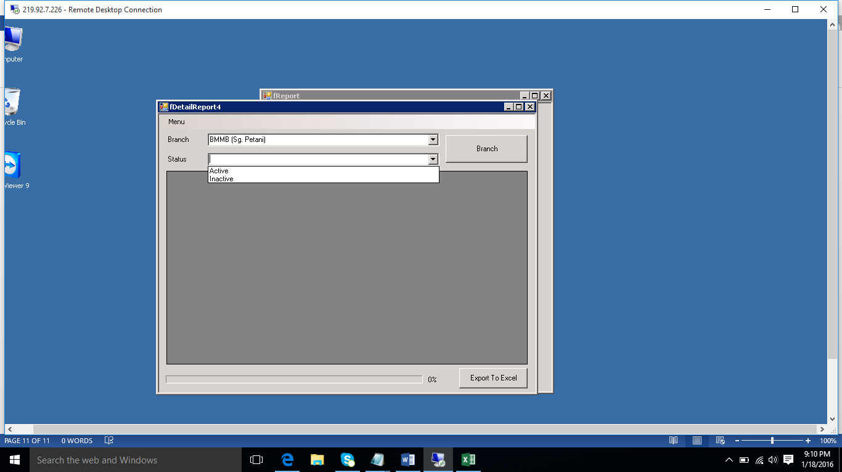

Click the “**Branch button”** for execute pulling the data

**Figure 6.2b: Selecting the Status of insurance Policy**

**Tip:**

*Note: *** indicate as caution*

After DMMS user click the “**Branch button”** and the DMMS application will pull the data from database *example figure 6.2 Detail Report- Branches Status*.

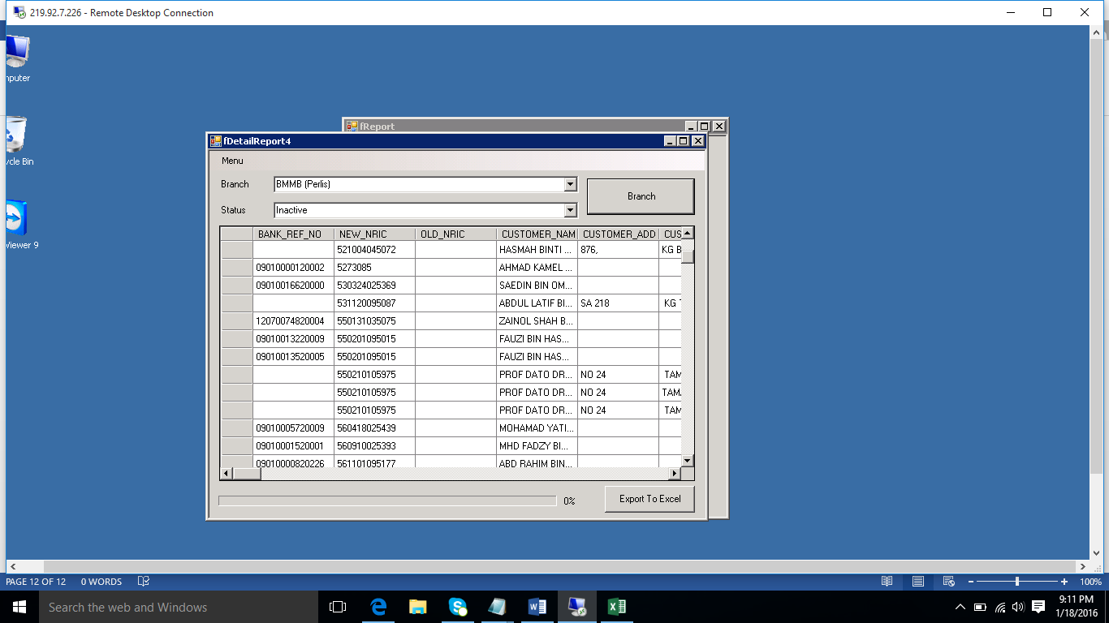

**Figure 6.2 Detail Report- Branches Status**

DMMS user able to export the data to Excel file, just click the button called **“Export to Excel”** *example figure 6.2 Detail Report- Branches Status*.

**Tip:**

*Note: *** indicate as caution*

**To start run DMMS application in Web Based**

In these DMMS web application is one of the facility to give DMMS user to add new insurance policy with new single insurance policy and search for single insurance policy.

The second facility to give DMMS user to pull out one single insurance policy and update renewed insurance policy where already expire date.

Third facility to give DMMS user auto general letter noted for those policy already expire and would like to inform renewed the insurance policy.

Four facility to give DMMS user generate payment in table and summary debit noted between BMM and TIIB.

Let’s go we have to explore each of the facility have inside the DMMS web application.

**Tip:**

*Note: *** indicate as caution*

**Step no 1.**

DMMS user have use Internet Browser run the DMMS web application once successful to log in AD, DMMS user just open internet Explorer(IE version 10 and above) and the DMMS application will auto display on the user log screen because we have set the DMMS web application default in internet browser, *example figure 7.0 : DMMS web application user login*

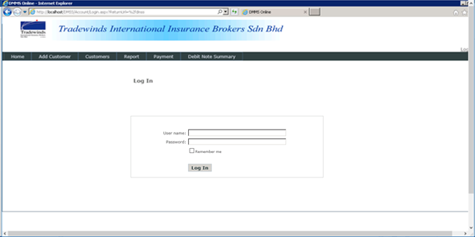

**Figure 7.0: DMMS web application user login**

**Tip:**

*Note: *** indicate as caution*

**Step no 2**

DMMS web application require DMMS user to entry the user name and password, *example figure 7.1 : Entry the User name and Password*



**Figure 7.1: Entry the User name and Password**

*** If DMMS user wrongly entry user name and password that system will display error where like *figure 7.2: Error Message invalid user name and password, please try again*

**Tip:**

*Note: *** indicate as caution*

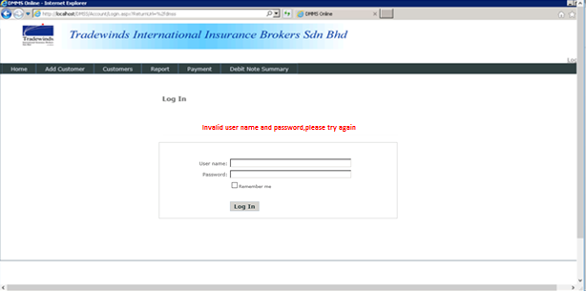

**Figure 7.2: Error message invalid user name and password, please try again.**

**Step no 3.**

After the DMMS user successfully to login the DMMS web application, DMMS user able to see all the DMMS web application module ready to function, *example figure 7.3 DMMS web application main page*

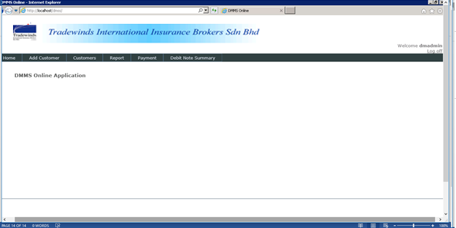

Use for log out the DMMS application

Welcome msg and user name display on right top corner

**Figure 7.3: DMMS web application main page**

DMMS user able to see user own user name display on right top corner and **“log off”,** if DMMS user want to log off the DMMS web application that they just click the “**“log off” to log out the system**

**Tip:**

*Note: *** indicate as caution*

**Add new insurance policy with new single insurance policy.**

As previously mention, DMMS user able to add new insurance policy into DMMS database using the DMMS web application. DMMS user have to follow step by step adding new insurance policy into DMMS database using DMMS web application

**Step no 1.**

DMMS user have to click the “Add Customer” in the web application navigation *example figure 7.4 Add new customer information in main page*

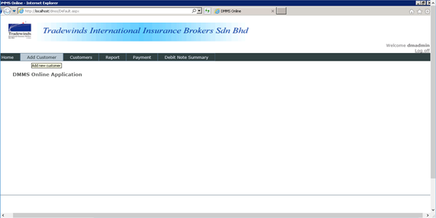

**Figure 7.4 Add new customer information in main page**

After DMMS user click the “Add Customer”, DMMS user will able to see DMMS eform(electronic form)for DMMS user to fill in all the information and all the eform input column is follow standard format where provide by TIIB DMMS user, *example figure 7.5 DMMS eform for add new customer information.*

*Noted to all DMMS user those input column have highlight * is compulsory to fill in the column.*

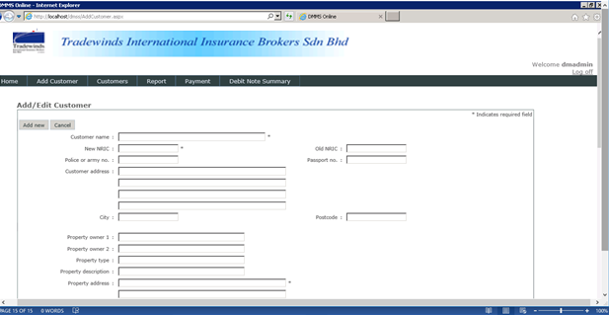

**Figure 7.5 DMMS eform for add new customer information**

**Tip:**

*Note: *** indicate as caution*

**Step no 2**

Once DMMS user completed to fill in all the column that DMMS user have to click the button called “ Add new” that system will start to store all the information into database ,*example figure 7.6 To save the customer information into DMMS database*

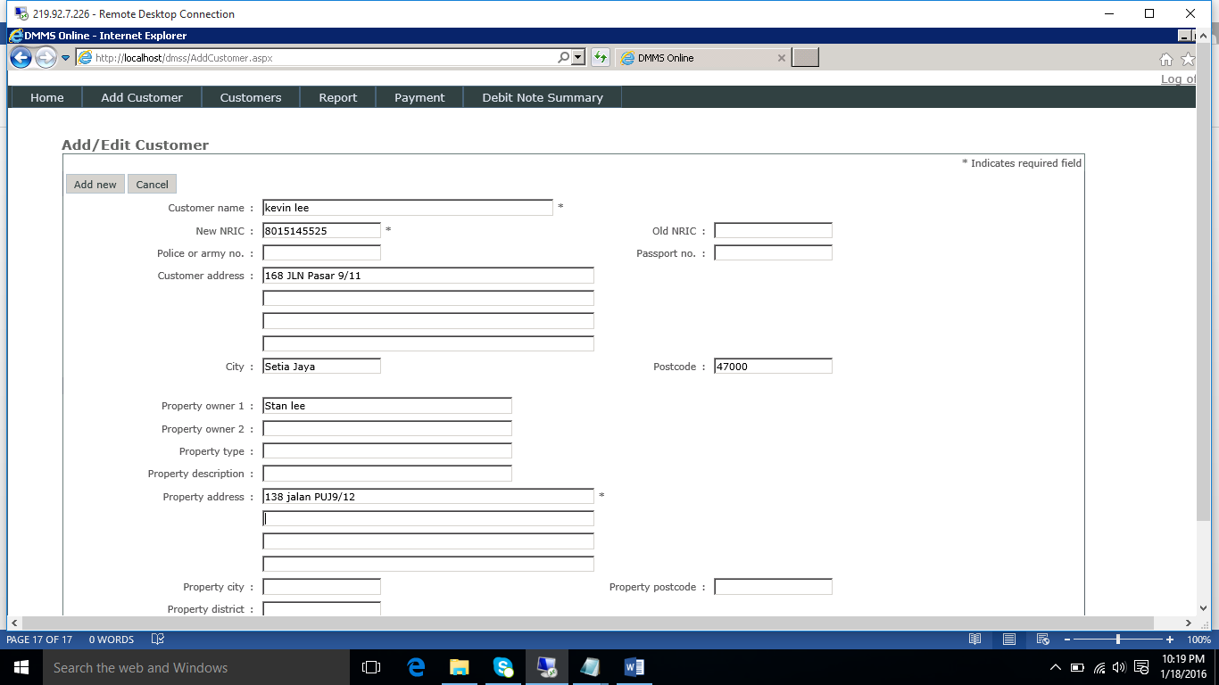

Click” add new” to save the information

**Figure 7.6 To save the customer information into DMMS database**

And the cancel button in beside the “Add New” button use for exist the add new customer eform and the system will back to main page once user click the “cancel” button.

**Search for single insurance policy**

DMMS user also able to use search function to search single insurance policy where inside the DMMS database.

**Step no 1**

DMMS user have to click the “customer” in the top navigation *example figure 7.7 select the customer list in main page.*

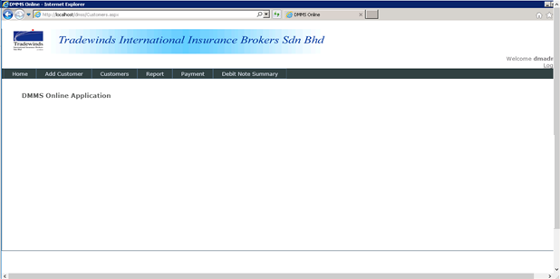

**Figure 7.7 select the customer list in main page**

**Step no 2**

Once the DMMS user click the “customer” in navigation that DMMS web application will display the search customer page *example figure 7.8 customer list*

DMMS user have to entry the New NIC no or Old NIC no / Passport no (if forest) and need to select which year data inside the database.

**Tip:**

*Note: *** indicate as caution*

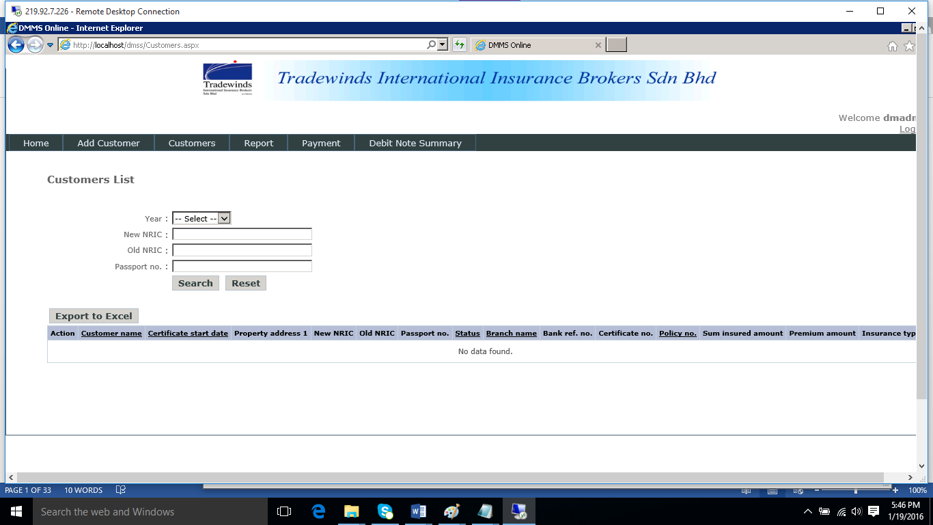

**Figure 7.8 customer list**

**Tip:**

*Note: *** indicate as caution*

**Auto generate letter note for those policy already expire and inform renewed the insurance policy.**

DMMS user able to generate the letter note for who the insurance holder policy already expire and request to renew. In this case DMMS user not need to manually to prepare the standard letter format using Microsoft word.

DMMS user just need to click the “Report” in the navigation*, example figure 8.0: Letter note in DMMS web application main page.*



**Figure 8.0: Letter note in DMMS web application main page.**

**Tip:**

*Note: *** indicate as caution*

Because DMMS web application is ready letter noted function for DMMS user to select which insurance holder policy need to generate letter noted and just fill in the NIC no in to column *example figure 8.1 Letter note in DMMS web application*.

**Step no 1**

DMMS user have to fill in the NIC no in input text column that click “Search” button.

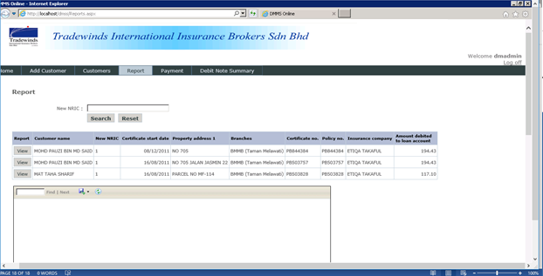

Click the search button to execute the search

Fill in the NIC no.

**Figure 8.1 Letter note in DMMS web application**

**Tip:**

*Note: *** indicate as caution*

**Step no 2**

Once the DMMS application already pull the data into table that DMMS user have to click the “View” button in the 1 column in the table that DMMS application will auto fill in all the information in the letter column where after the table ,*example figure 8.2 letter note function*

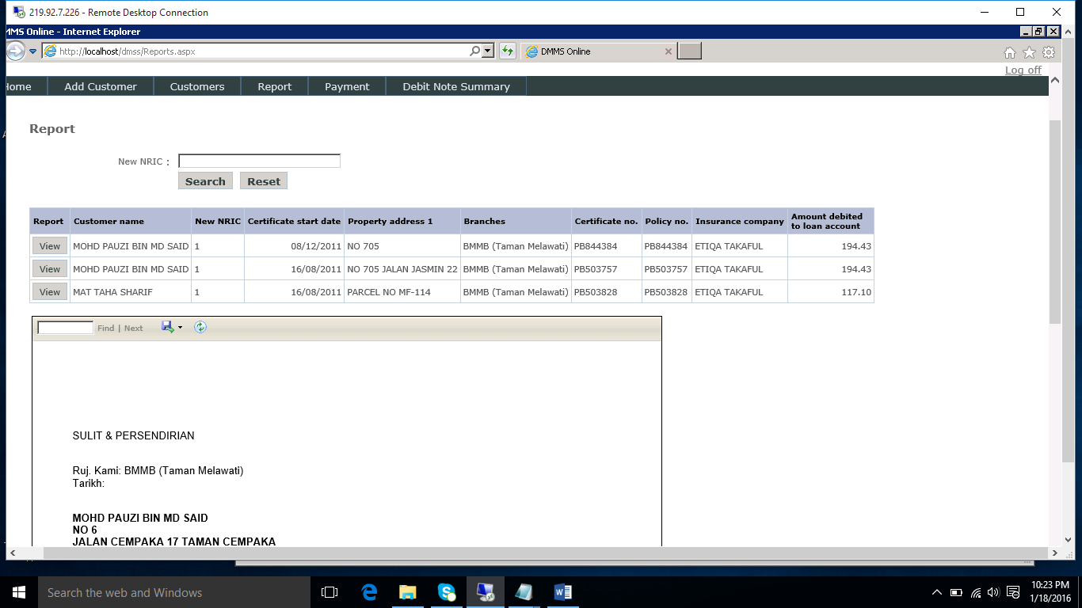

Click the view button to fill in the information

Letter column

**Figure 8.2 letter note function**

At the same time, DMS user able to save the letter note in local PC location or external storage *example figure 8.3 Save the letter note in in local PC location or external storage*

**Tip:**

*Note: *** indicate as caution*



Click Save icon for save the letter note into local PC or External storage

**Figure 8.3 Save the letter note in in local PC location or external storage**

DMMS user have choice to select “open” immediately open the letter into Ms word or click “SAVE” find the file location to save *example figure 8.4 select the file location*

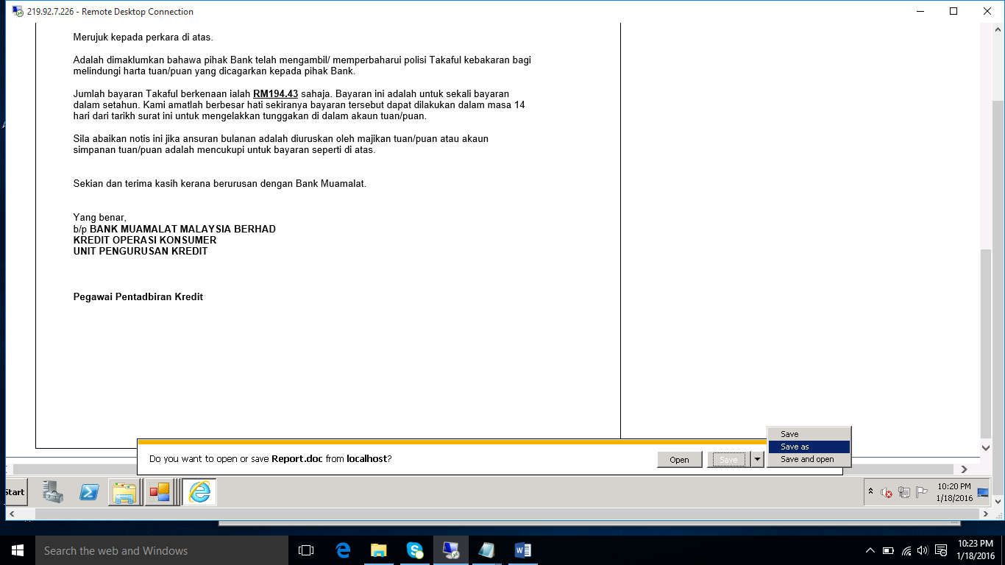

**Figure 8.4 select the file location**

**Payment settlement**

DMMS user also able to use DMMS web application to pull the insurance policy from database and do the insurance payment settlement.

**Step no 1**

DMMS user have to click the “Payment” in top navigation *example figure 8.5 select the payment button in main page*

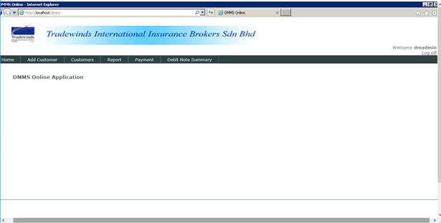

**Figure 8.5 select the payment button in main page**

**Tip:**

*Note: *** indicate as caution*

Once the DMMS user click the **“Payment”** in top navigation that DMMS web application will display the payment settlement page, *example figure 8.6 Payment settlement page*

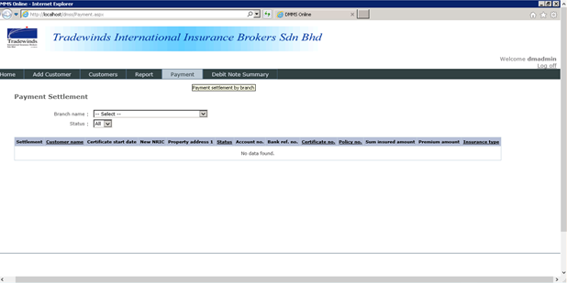

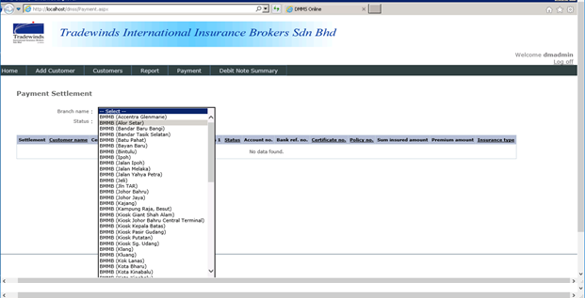

**Figure 8.6 Payment settlement page**

Before DMMS user start pull the insurance policy , DMMS user have to know the particular insurance policy belong to which branch because DMMS user have to select which branch *example figure 8.6 Payment settlement page.*

DMMS user also have choice to select status of the insurance policy, example select Status **“Yes”** mean the insurance policy still haven’t settlement yet

If select **“NO”** mean the settlement have completed.

**Step no 2**

DMMS user once select the Branch name and status “No”, after that DMMS web application will auto pull all the information based on the condition. Example figure 8.9 Payment Settlement table.

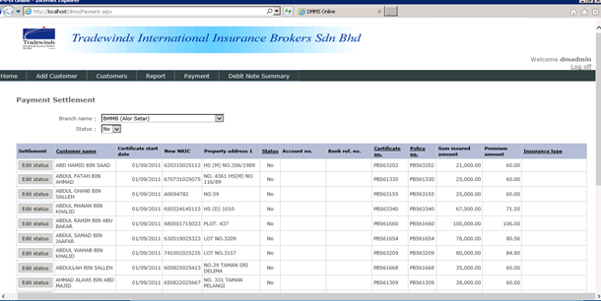

“Edit status” button

**Figure 8.9 Payment Settlement table.**

DMMS user have to select which customer name want to edit as payment settlement with click the “Edit status” button in the settlement table, *example figure 8.9 Payment Settlement table.*

**Step no 3**

DMMS user need to change the Status column to “Yes” and following click the Save button but if DMMS user click the “Cancel” button mean the information is not updated, *example figure 9.0 update payment settlement*

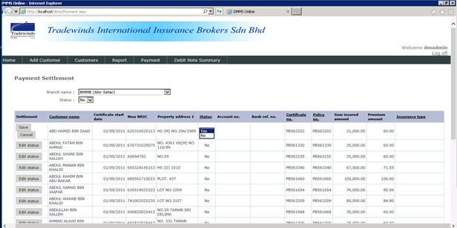

Click the “SAVE”

change the Status column to “Yes”

**Figure 9.0 update payment settlement**

*\*\*\*\*note: once the status update to “YES” the column will disappear in the “NO” table because the column is belong to “YES” table if you want to find back DMMS user have to change the status to “YES” in top drop list. It is mean the status drop list in local in after Branch name*

**Debit Note Summary**

As the DMMS user request to add one function called Debit Noted Summary into DMMS web application to pull all information by every BMM branch and execute the auto calculation based on the TIIB DMMS user provide standard Debit Noted Summary excel file.

**Step no 1**

DMMS user have to click the **“Debit Noted Summary”** in top navigation *example figure 10 select the Debit Noted Summary button in main page*



**Figure 10 select the Debit Noted Summary button in main page**

**Step no 2**

DMMS user have to select the Branch name and start date which start pull data date and select the End date which mean until what date, *example figure 10.1 Debit Note Summary in DMMS web application and Figure 10.1a Select the Expired date.*

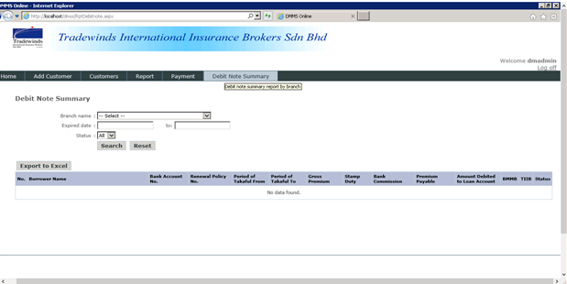

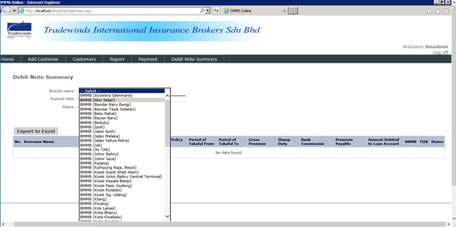

Select the Branch name

**Figure 10.1 Debit Note Summary in DMMS web application**

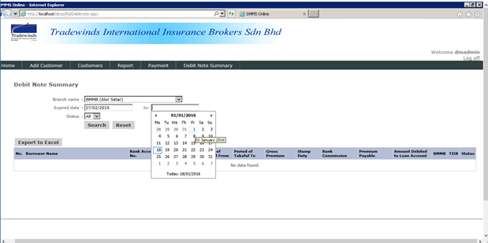

**Figure 10.1a Select the Expired date.**

After DMMS user completed to select the start Expired date and also end date of the pulling data, DMMS user also have optional to choose whether want to pulling the data with “Yes” or “NO” both status before click the Search Button.

*Example Figure 10.2 selecting the status condition before execute pull in data from DMMS database*

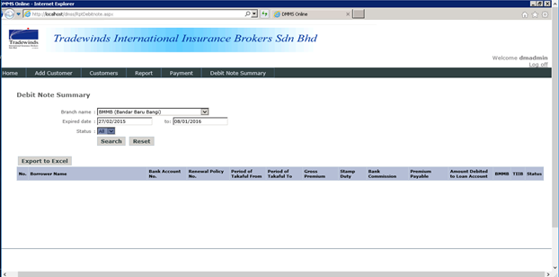

Click Search button to start pull the data information from database

Click Export to Excel mean export all the information after successful pull the data from database

**Figure 10.2 selecting the status condition before execute pull in data from DMMS database**

**Step no 3**

After DMMS web application successful pull the data from DMMS database that all the information will fill in into table ready in the Debit Note Summary page, example figure 10.3 Debit Note summary information successful from DMMS database.

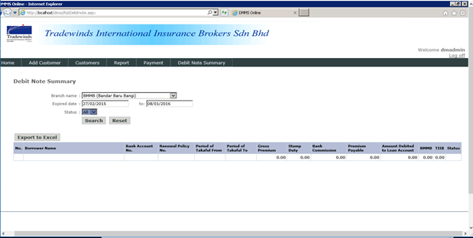

Export all the information inside the table to excel file.

**Figure 10.3 Debit Note summary information successful from DMMS database**

**Step no 4**

DMMS user able to export all the information inside the Debit Note Summary table to excel file if the DMMS user want save one copy in local PC storage or external storage, *example figure 10.3 Click the Export to Excel button*

**Tip:**

*Note: *** indicate as caution*

**Step No 5**

DMMS Web application given option to DMMS user to choose **“OPEN”** to Excel file or Want to “SAVE” which storage location, *example figure 10.4 selecting file storage location.*

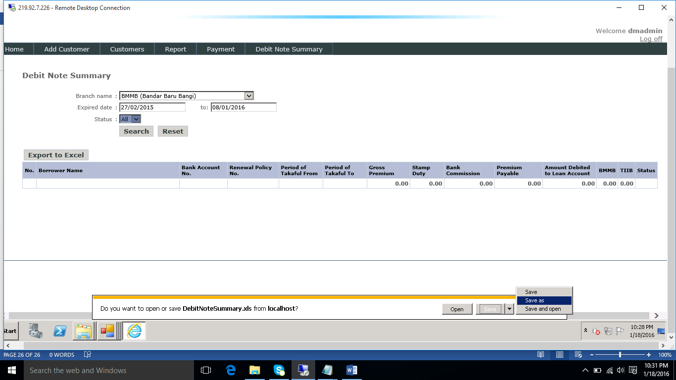

Choose “SAVE AS”, keep the file location

Choose “OPEN” to Excel file

**Figure 10.4 selecting file storage location**

**Step no 6**

Once DMMS user select “SAVE AS” that DMMS web application will display other screen to select the file location *example figure 10.5 selecting SAVE AS file location.*

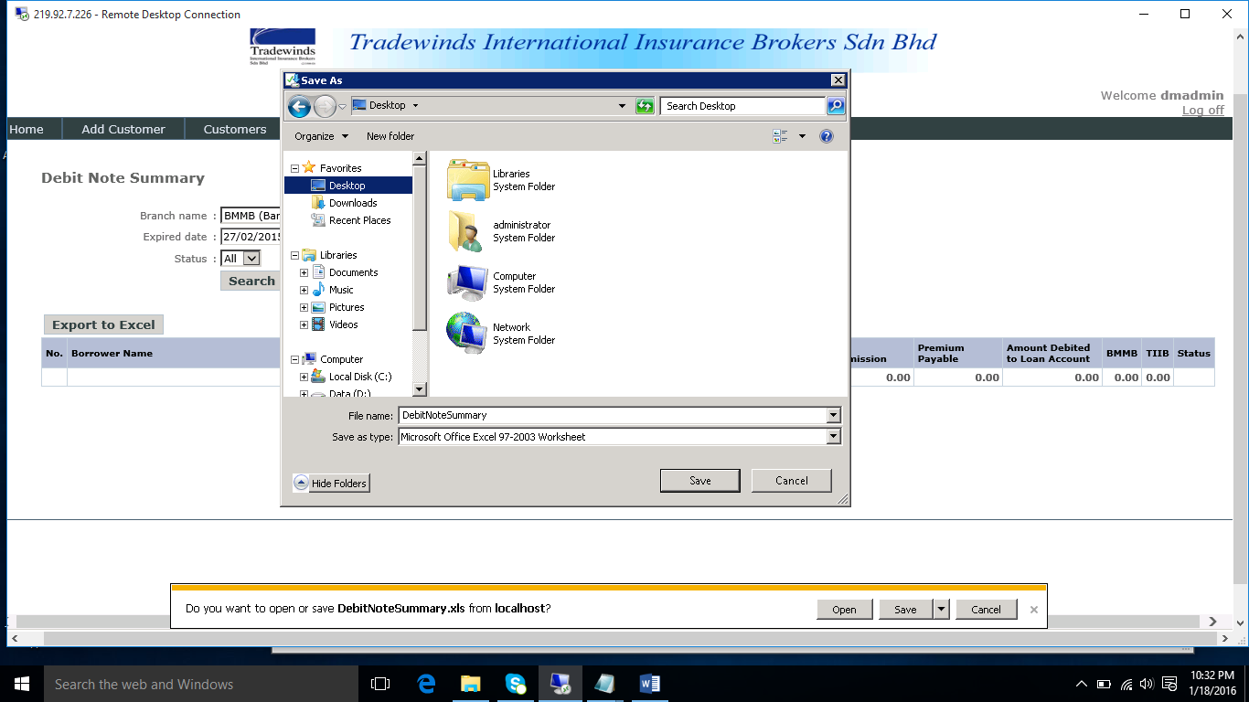

**Figure 10.5 selecting SAVE AS file location**

**Step no 7**

After the file location selected and DMMS user able to check back the file whether is successful to selected file location, *example figure 10.6 confirmation file is successful save in location selected*

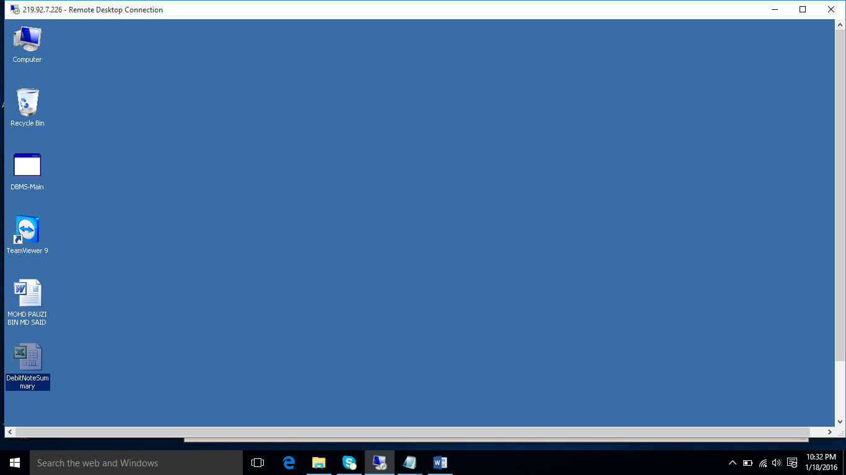

**Figure 10.6 confirmation file is successful save in location selected**

**Tip:**

*Note: *** indicate as caution*

**Step no 8**

DMMS user also able to open back the file export from DMMS web application with correct information pull by DMMS web Application. Example figure 10.7 confirmation whether correct information pull by DMMS web Application.

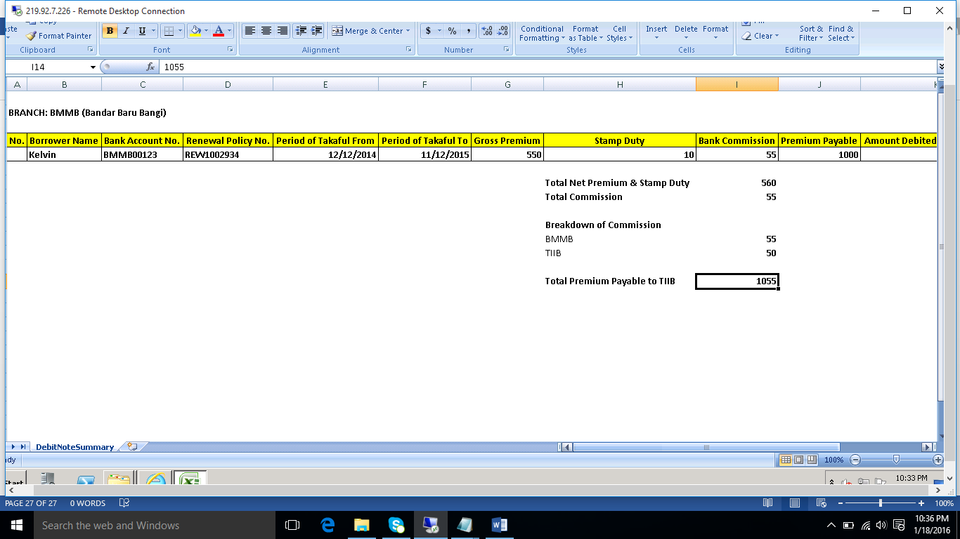

**Figure 10.7 confirmation whether correct information pull by DMMS web Application**